Chieu Le Heng CS4131 Project

**Oxet** An app for users to create and use courses based on sentence flashcards for languages that are not widely spoken

Fragments/Screens

**Profile (gamification)**

n-day streak, total and weekly points

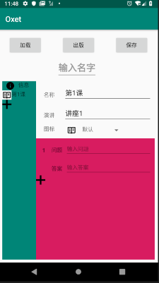**Edit Courses (create courses)**

File picker for selecting file in internal device storage to load

Master-detail layout for editing different lessons in the language

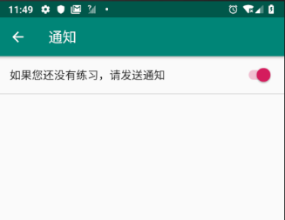Communication and syncing of TextViews and ImageViews between Edit Courses’ different sub-fragments and RecyclerView adapters.

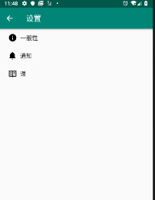

**Settings**

Whether to show notifications

**Language**

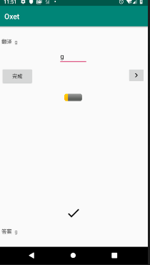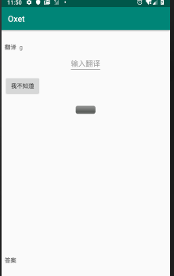Just shows the language’s name, description and list of lessons

**Lesson**

An exercise running through the sentences in a lesson

Users need to type in translations to questions

ProgressBar to show the progress through the exercise

Background/miscellaneous functions

**Flashcard**

Levels of familiarity 1,2,3…, with 1 being the most unfamiliar.

Correct answers move the flashcard up a level (add 1 to level), and wrong answers move the flashcard down a level (subtract 1 to level if level isn’t 1)

Level *n* flashcards are meant to be tested every 2n-1 days.

Flashcards are sorted and shown to user by how long it is after when the flashcard is supposed to be tested (which is lastTestedDate + interval, where interval = 2n-1 days)

**File IO**

Basic JSON file format for storing languages and app usage history/gamification information

**Internationalisation**

* 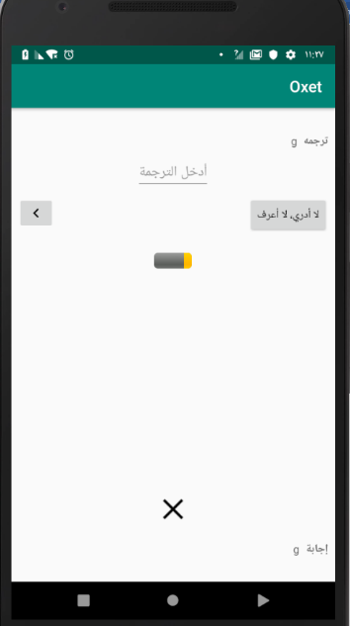Translated strings to Chinese and Arabic
* mirrored (RTL) a rightward arrow icon-button to become leftward
* supports numerals (e.g. Eastern Arabic numerals: ०۱۲۳۴۵۶۷۸۹) other than the standard Western Arabic Numer als (0123456789)
* Implements plural when translating “%d day streak” to Arabic

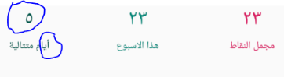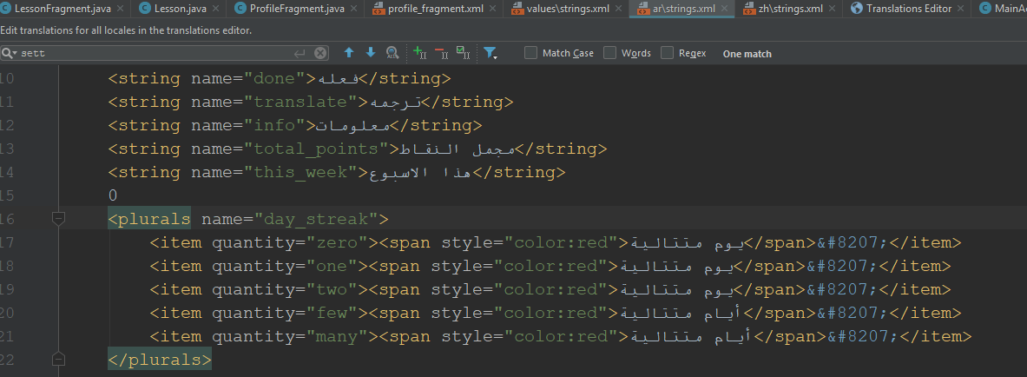

0 day streak

5 day streak

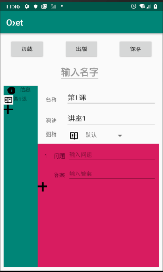

* “第%d课” as compared to “Lesson %d”: custom ordinals

**Notifications**

Sent at 8pm every day if user has not practiced today and has set notifications to true in settings

Directs user to app when clicked